1. **Get all the information of all Students.**

**SQL Query and the Results**

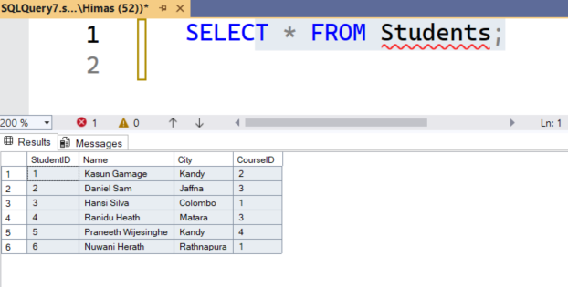

**B. Select student id, name, and city from students who are from 'Kandy'**

**SQL Query and the Results**

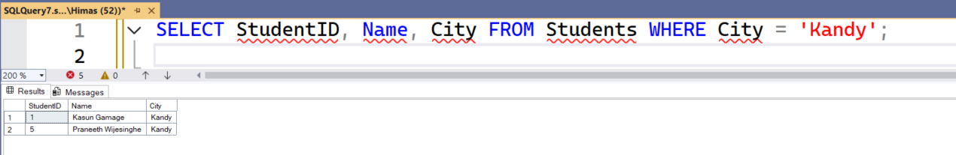

1. **Update the City as 'Galle' for the student whose ID equals 4**

**SQL Query**

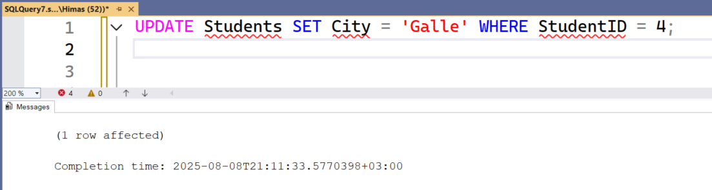

1. **Get all the information of all students with their course names**

**SQL Query and the Results**

